Name : Soumya Dixit

PRN : 23070521151  
Batch : B2

Sem : 5

**Task : 1**

<script>

let ages = [15, 16, 17, 18, 19];

console.log("Original Ages:", ages);

ages.push(20);

console.log("After push(20):", ages);

ages.pop();

console.log("After pop():", ages);

console.log("Array length:", ages.length);

let doubles = ages.map(age => age * 2);

console.log("Doubles:", doubles);

let cubes = ages.map(age => age ** 3);

console.log("Cubes:", cubes);

</script>

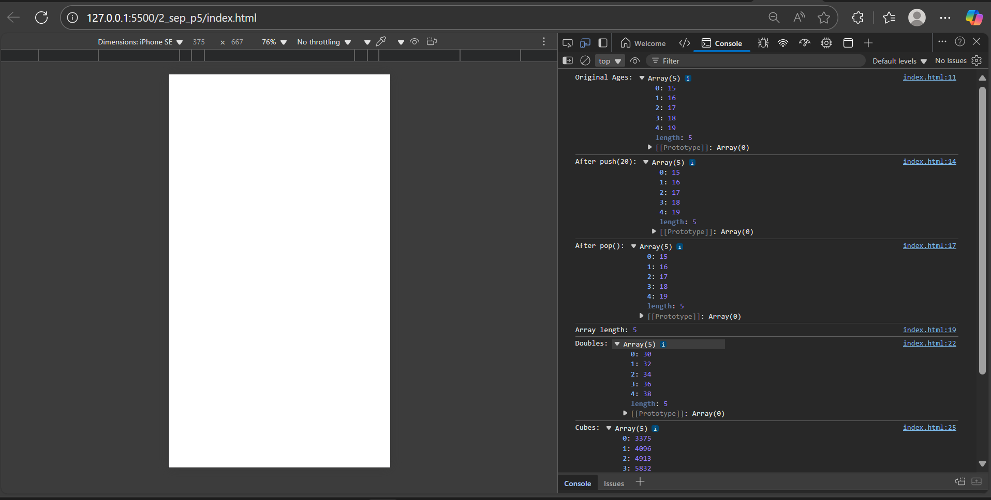

**Task : 2**

<script>

let numbers = [5, 10, 15, 20, 25, 30, 35, 40, 45, 50];

let sum = 0;

for (let i = 0; i < numbers.length; i++) {

sum += numbers[i];

}

alert("Array Elements: " + numbers.join(", ") + "\nSum of Elements: " + sum);

</script>

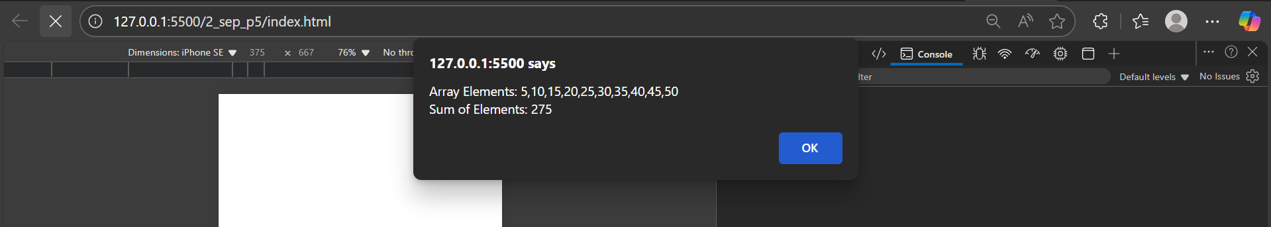

**Task : 3**

<script>

let students = [

{ id: 1, name: "Aarav", marks: 72 },

{ id: 2, name: "Isha", marks: 45 },

{ id: 3, name: "Rohan", marks: 88 },

{ id: 4, name: "Priya", marks: 55 },

{ id: 5, name: "Kabir", marks: 39 }

];

let studentNames = students.map(s => s.name);

console.log("Student Names:", studentNames);

let passedStudents = students.filter(s => s.marks > 50);

console.log("Passed Students:", passedStudents);

let totalMarks = students.reduce((sum, s) => sum + s.marks, 0);

let avgMarks = totalMarks / students.length;

console.log("Average Marks:", avgMarks);

console.log("Report Card:");

students.forEach(s => {

console.log(`${s.name} (ID: ${s.id}) - Marks: ${s.marks}`);

});

</script>

